Задание 1.

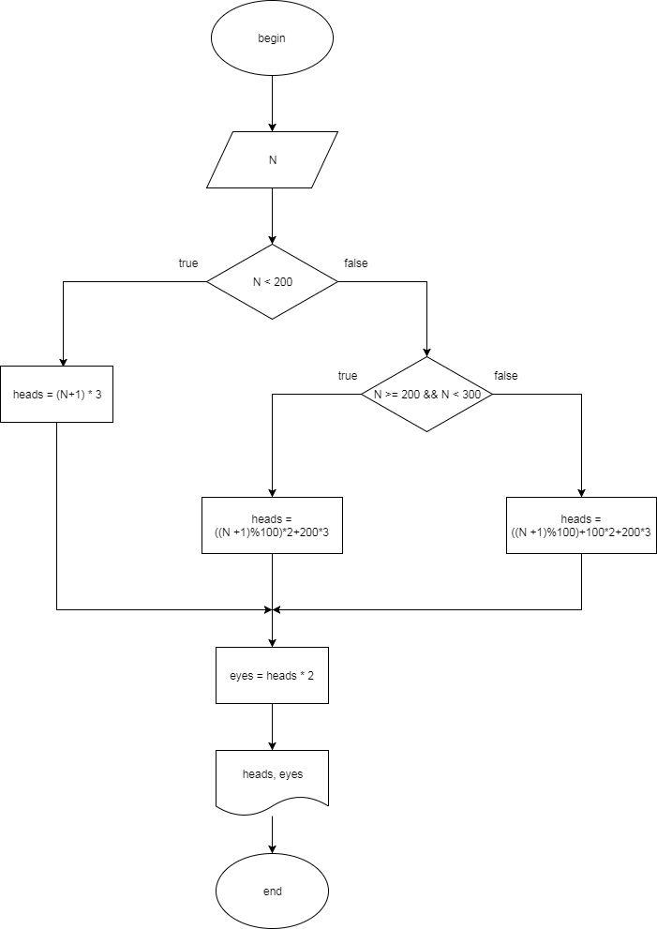

public class Task21 {  
 public static void run() {  
 System.*out*.println("----------Task 2.1:");  
 int N = 145;  
 System.*out*.println("Number of heads: " + *getHeadsNumber*(N));  
 System.*out*.println("Number of eyes: " + *getEyesNumber*(N));  
 }  
  
 public static int getHeadsNumber(int n) {  
 if (n < 200) {  
 return (n + 1) \* 3;  
 } else if (n >= 200 && n < 300) {  
 return ((n + 1) % 100) \* 2 + 200 \* 3;  
 } else {  
 return ((n + 1) % 100) + 100 \* 2 + 200 \* 3;  
 }  
 }  
  
 public static int getEyesNumber(int n) {  
 return *getHeadsNumber*(n) \* 2;  
 }  
}

Задание 2.

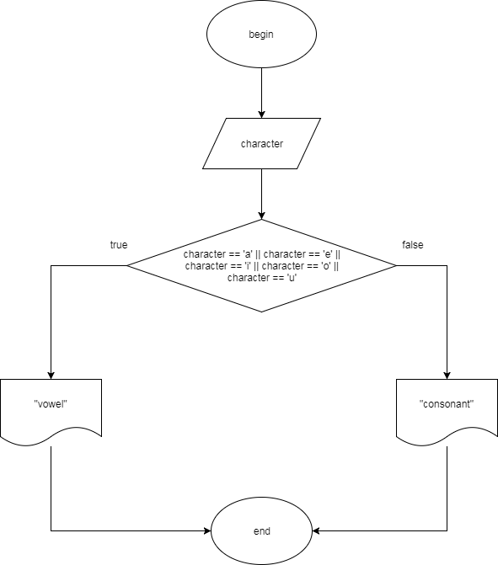

public class Task22 {  
 public static void run() {  
 System.*out*.println("----------Task 2.2:");  
 char input1 = 's';  
 System.*out*.println("Letter " + input1 + " is a " + *getLetterType1*(input1));  
 char input2 = 'w';  
 System.*out*.println("Letter " + input2 + " is a " + *getLetterType2*(input2));  
 char input3 = 'a';  
 System.*out*.println("Letter " + input3 + " is a " + *getLetterType3*(input3));  
 char input4 = 'd';  
 System.*out*.println("Letter " + input4 + " is a " + *getLetterType4*(input4));  
 char input5 = 'f';  
 System.*out*.println("Letter " + input5 + " is a " + *getLetterType5*(input5));  
 }  
  
 public static String getLetterType1(char c) {  
 switch (c) {  
 case 'a':  
 case 'A':  
 case 'e':  
 case 'E':  
 case 'i':  
 case 'I':  
 case 'o':  
 case 'O':  
 case 'u':  
 case 'U':  
 return "vowel";  
 default:  
 return "consonant";  
 }  
 }  
  
 public static String getLetterType2(char c) {  
 if (c == 'a' || c == 'A' || c == 'e' || c == 'E' ||  
 c == 'i' || c == 'I' || c == 'o' || c == 'O' || c == 'u' || c == 'U') {  
 return "vowel";  
 }  
 return "consonant";  
 }  
  
 public static String getLetterType3(char c) {  
 int a = 'a';  
 int A = 'A';  
 int e = 'e';  
 int E = 'E';  
 int i = 'i';  
 int I = 'I';  
 int o = 'o';  
 int O = 'O';  
 int u = 'u';  
 int U = 'U';  
 if (c == a || c == A || c == e || c == E || c == i || c == I || c == o || c == O || c == u || c == U) {  
 return "vowel";  
 }  
 return "consonant";  
 }  
  
 public static String getLetterType4(char c) {  
 String s = "" + c;  
 s = s.toLowerCase();  
 if ("a".equals(s) || "e".equals(s) || "i".equals(s) || "o".equals(s) || "u".equals(s)) {  
 return "vowel";  
 } else {  
 return "consonant";  
 }  
 }  
  
 public static String getLetterType5(char c) {  
 String s = "" + c;  
 switch (s.toLowerCase()) {  
 case "a":  
 case "e":  
 case "i":  
 case "o":  
 case "u":  
 return "vowel";  
 default:  
 return "consonant";  
 }  
 }  
}

Задание 3.

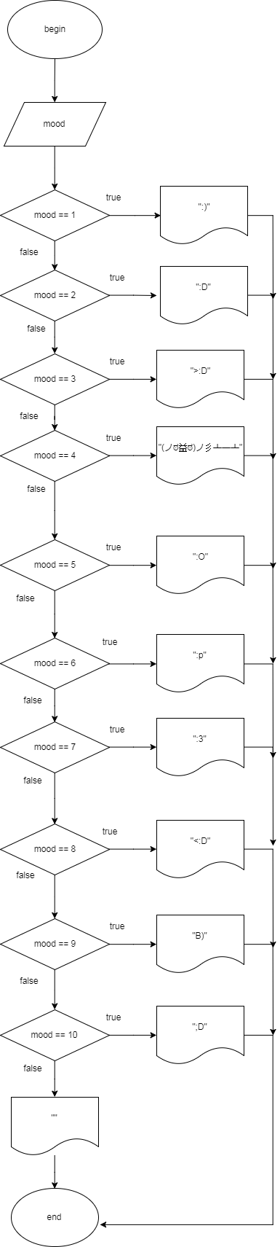

public class Task23 {  
 public static void run() {  
 System.*out*.println("----------Task 2.3:");  
 Random rand = new Random();  
 int mood = rand.nextInt(11) + 1;  
 System.*out*.println(*getMood*(mood));  
 }  
  
 public static String getMood(int n) {  
 switch (n) {  
 case 1:  
 return ":)";  
 case 2:  
 return ":D";  
 case 3:  
 return ">:D";  
 case 4:  
 return "(ノಠ益ಠ)ノ彡┻━┻";  
 case 5:  
 return ":O";  
 case 6:  
 return ":p";  
 case 7:  
 return ":3";  
 case 8:  
 return "<:D";  
 case 9:  
 return "В)";  
 case 10:  
 return ";D";  
 default:  
 return "";  
 }  
 }  
}

Задание 4.

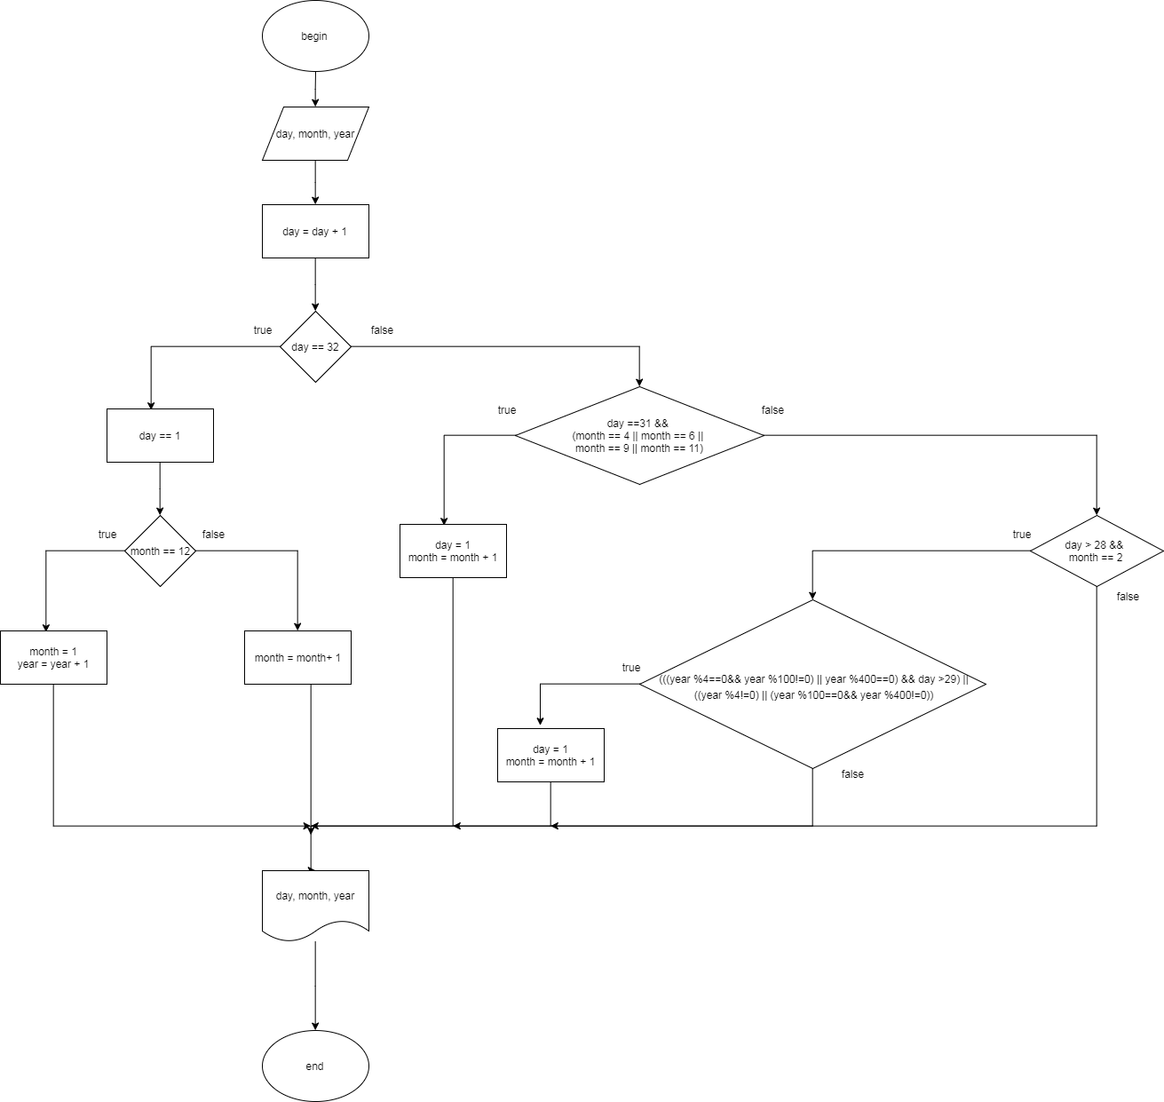

public class Task24 {  
 public static void run() {  
 System.*out*.println("----------Task 2.4:");  
 int day = 30;  
 int month = 1;  
 int year = 2018;  
 System.*out*.println("Tomorrow's date is " + *getTomorrowDate*(day, month, year));  
 }  
  
 public static String getTomorrowDate(int day, int month, int year) {  
 int d = day + 1;  
 int m = month;  
 int y = year;  
 if (d == 32) {  
 d = 1;  
 if (m == 12) {  
 m = 1;  
 y++;  
 } else {  
 m++;  
 }  
 } else if (d == 31 && (m == 4 || m == 6 || m == 9 || m == 11)) {  
 d = 1;  
 m++;  
 } else if (d > 28 && m == 2) {  
 if ((((y % 4 == 0 && y % 100 != 0) || y % 400 == 0) && d > 29) ||  
 ((y % 4 != 0) || (y % 100 == 0 && y % 400 != 0))) {  
 d = 1;  
 m++;  
 }  
 }  
 return "" + d + "-" + m + "-" + y;  
 }  
}

Задание 5.

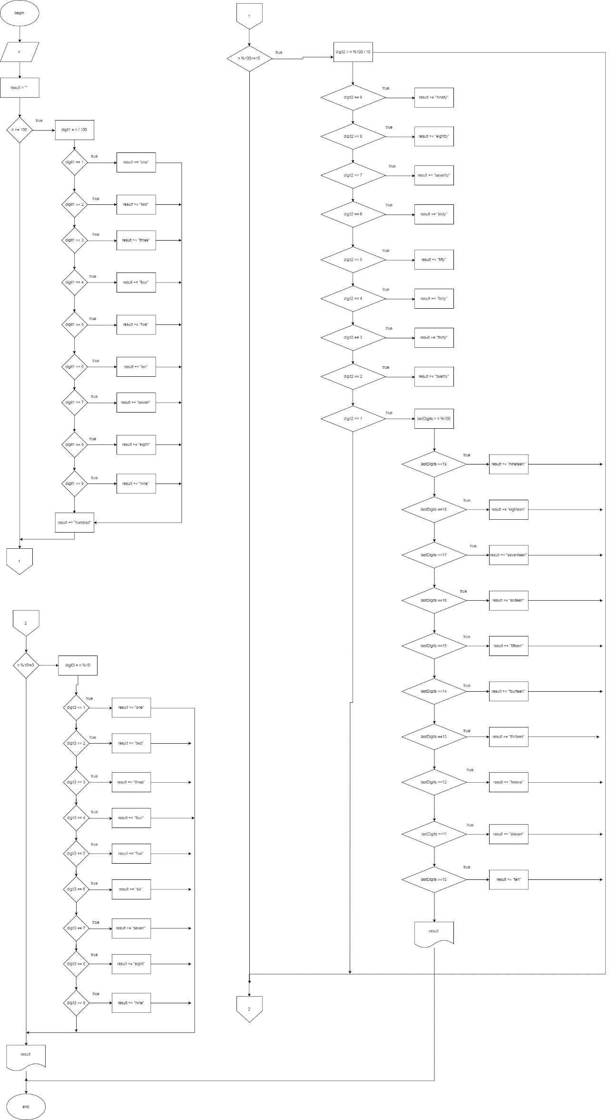

public class Task25 {  
 public static void run() {  
 System.*out*.println("----------Task 2.5:");  
 System.*out*.println("Enter a number from 1 to 999: ");  
 Scanner reader = new Scanner(System.*in*);  
 int input = reader.nextInt();  
 reader.close();  
 System.*out*.println(*getNumberAsString*(input));  
 }  
  
 public static String getNumberAsString(int n) {  
 String result = "";  
 if (n >= 100) {  
 int digit1 = n / 100;  
 if (digit1 == 1) {  
 result += "one ";  
 }  
 if (digit1 == 2) {  
 result += "two ";  
 }  
 if (digit1 == 3) {  
 result += "three ";  
 }  
 if (digit1 == 4) {  
 result += "four ";  
 }  
 if (digit1 == 5) {  
 result += "five ";  
 }  
 if (digit1 == 6) {  
 result += "six ";  
 }  
 if (digit1 == 7) {  
 result += "seven ";  
 }  
 if (digit1 == 8) {  
 result += "eight ";  
 }  
 if (digit1 == 9) {  
 result += "nine ";  
 }  
 result += "hundred ";  
 }  
 if (n % 100 >= 10) {  
 int digit2 = n % 100 / 10;  
 if (digit2 == 9) {  
 result += "ninety ";  
 }  
 if (digit2 == 8) {  
 result += "eighty ";  
 }  
 if (digit2 == 7) {  
 result += "seventy ";  
 }  
 if (digit2 == 6) {  
 result += "sixty ";  
 }  
 if (digit2 == 5) {  
 result += "fifty ";  
 }  
 if (digit2 == 4) {  
 result += "forty ";  
 }  
 if (digit2 == 3) {  
 result += "thirty ";  
 }  
 if (digit2 == 2) {  
 result += "twenty ";  
 }  
 if (digit2 == 1) {  
 int lastDigits = n % 100;  
 if (lastDigits == 19) {  
 result += "nineteen";  
 }  
 if (lastDigits == 18) {  
 result += "eighteen";  
 }  
 if (lastDigits == 17) {  
 result += "seventeen";  
 }  
 if (lastDigits == 16) {  
 result += "sixteen";  
 }  
 if (lastDigits == 15) {  
 result += "fifteen";  
 }  
 if (lastDigits == 14) {  
 result += "fourteen";  
 }  
 if (lastDigits == 13) {  
 result += "thirteen";  
 }  
 if (lastDigits == 12) {  
 result += "twelve";  
 }  
 if (lastDigits == 11) {  
 result += "eleven";  
 }  
 if (lastDigits == 10) {  
 result += "ten";  
 }  
 return result;  
 }  
 }  
 if (n % 10 != 0) {  
 int digit3 = n % 10;  
 if (digit3 == 1) {  
 result += "one";  
 }  
 if (digit3 == 2) {  
 result += "two";  
 }  
 if (digit3 == 3) {  
 result += "three";  
 }  
 if (digit3 == 4) {  
 result += "four";  
 }  
 if (digit3 == 5) {  
 result += "five";  
 }  
 if (digit3 == 6) {  
 result += "six";  
 }  
 if (digit3 == 7) {  
 result += "seven";  
 }  
 if (digit3 == 8) {  
 result += "eight";  
 }  
 if (digit3 == 9) {  
 result += "nine";  
 }  
 }  
 return result;  
 }  
}